MyTimetable Introduction
When opening MyTimetable for the very first time you will need to log in (top right). Although anyone can open the site, only City students and staff can log in. Logging in will automatically save your searches for the next time. Initially your display will contain no data and it will have defaulted to ‘Timetable View’, which is the correct view for looking up course/programme timetables. If you wish to look up estate timetables to check specific rooms or buildings please click on ‘Estate View’ instead.
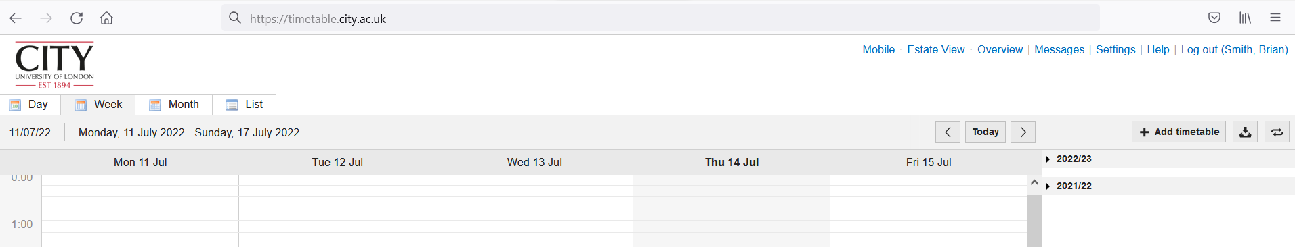

After clicking on ‘Estate View’ your screen will look the same except for the name of the link you just clicked on. Now it will be the name of the other view. This is where you click whenever you wish to switch between viewing course/programme timetables or Estate timetables.
The Help section can be accessed from the top right, beside your logout. Please use this if you need assistance. When opened, simply use the shortcuts on the left to access the pertinent section.
- Both of the two Views have tabs on the left for Day, Week, Month and List. This determines what format you will see the data in on your screen.
- The ‘Estate View’ has multiple versions of List that you might find useful when looking up room or building timetables.
- To select the data you want to see click on ‘Add Timetable’ on the right-hand side. Ensure you choose from the appropriate academic year.
Your selected data will be uploaded to your screen. You may make multiple selections. When you are in ‘Timetable View’ (for looking up course timetables) and choose the ‘List’ view you will notice an extra dropdown box appear at the top titled ‘Month from selected day’. This is another method of choosing your date range. You can choose the entire academic year, individual terms or specific weeks. This drop-down box allows you to choose the academic year. Please ensure you choose from the appropriate academic year.

Removing selected data
If you have logged in then your chosen searches will remain on display until you remove them.
For students who receive a personalised timetable it is important to manage any manually added items, so they do not confuse your view.
Please remove these by moving your cursor to the vertical pane on the right.
- Hover over the manually chosen item. (Manually chosen items are those that do not have a black-filled box next to them.) It might be a Programme, a Planning Set or a Module.
- You will see three dots appear.
- Left click on the three dots and select ‘Remove’.
- Repeat for all manually chosen items.
Now you will be left with just your personal timetable. Do not worry; you cannot remove any sessions of your automatically generated personal timetable.

Downloading your selected data
To download a printable version of the data you have chosen please click on the download icon to the right of + Add Timetable, shown as
This will offer you a range of formats. If you wish to look over an entire module or a programme it might easier to read through your data on one of these than toggle back and forth on your on-screen view.
After clicking the download icon, choose your date range from the vertical list on the right-hand side of the pop-up box before clicking ‘Download’.
Please note the final three columns on the Excel download (L, M and N) are for internal reporting and may be disregarded.

Personalised Timetables
Students whose programmes receive a personalised timetable will be able to view these from early in the autumn term. The timetable will upload automatically and you will be able to see this when you log in. Please check back regularly from mid-September.
Academic colleagues will see their personal timetable upon logging in. If it is not there, please contact Timetabling@city.ac.uk who will enable this feature.
Alternatively, any member of staff can choose to view the timetable for an academic colleague if they are assigned to teaching.

iCalendars
Students and staff can connect their timetable to an external calendar using the share button on the top right and following the onscreen instructions.

A full detailed help section is available on the site. Or else if you have any queries please contact Timetabling@city.ac.uk

